



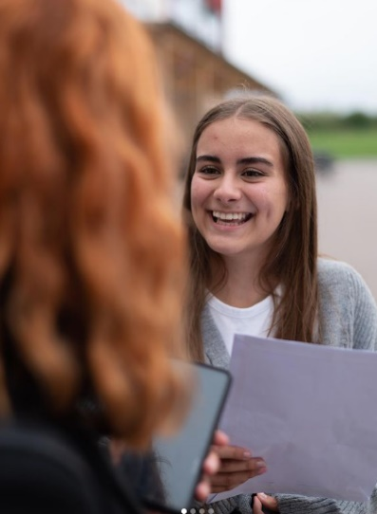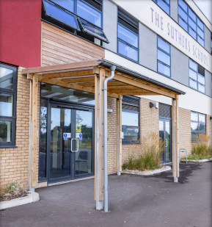

**YEAR 9 CURRICULUM**

**2024/2025**

**INTRODUCTION FROM MISS WATKIN: HEAD TEACHER**

Dear Parents & Carers,

The Suthers School promises to deliver a highly academic curriculum and to empower the young people of Newark to do more than they ever thought possible. During your time here at The Suthers School, you will learn how to become the best version of yourself, by committing to your studies and taking part in all the opportunities you are faced with, grasping them in both hands.

We offer a curriculum that meets the needs of all students, providing exciting enrichment opportunities which guarantees access to a wealth of extra-curricular activities and student leadership responsibilities.

**Nic Watkin**

Head Teacher

**2024 RESULTS**

We were incredibly proud to celebrate our second set of GCSE results this summer. There were some incredible individual performances and all students have gone on to secure their chosen pathway at Post-16. Academic performance, along with a commitment to character development, is a key focus for all students at The Suthers School.

**THE SUTHERS WAY**

The Suthers School is a calm, safe, purposeful, and positive place to learn. Our aim is for all lessons to be free from disruption. The behaviour system is designed to provide a consistent approach across all lessons and to prevent persistent low-level disruption. Teachers will at all points aim to use positive framing to support their approach, but our ambitious standards must be adhered to.

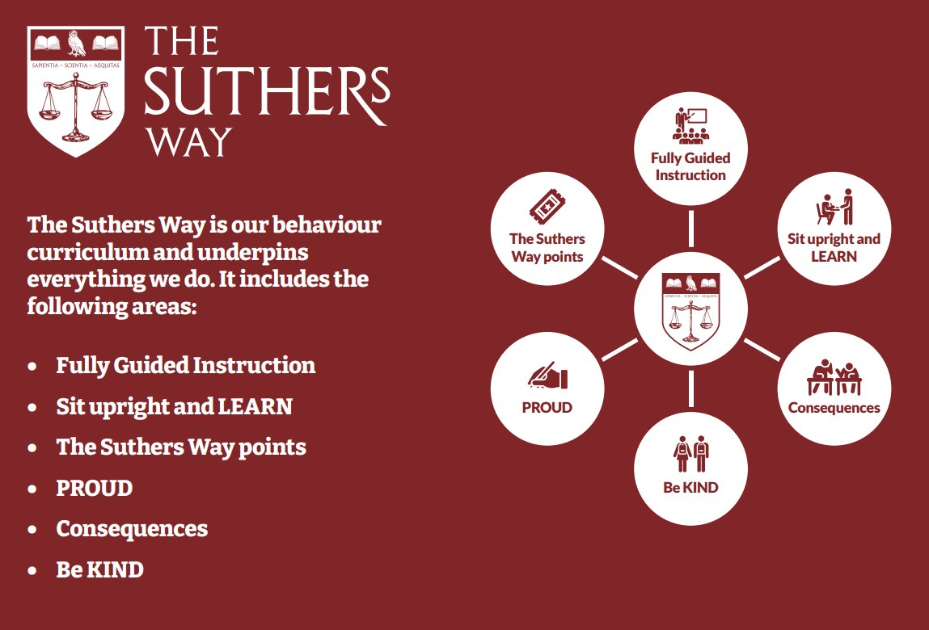

**EXTRA CURRICULAR & ENRICHMENT**

We know that young people need both a strong academic foundation and well-developed character strengths to succeed in education and the world beyond. That’s why we are committed to delivering an extensive enrichment programme—and through our extended school day we are able to guarantee participation for all, no matter what their starting point.

Our extended curriculum provides all pupils with guaranteed access to an exciting range of activities; from German language lessons and computer programming to creative arts, sport, leadership, charity work, sports clubs and running a student newsletter- students at The Suthers School benefit from a truly enriching curriculum.

Our current Enrichment provision is as follows:

|  |  |  |
| --- | --- | --- |
| Tuesday | Wednesday | Thursday |
| The Suthers Collective Orchestra**  Boxing  Warhammer Club | Arts Awards TBC  Cooking Club  S29 Drama Club TBC  Netball (PE Department)  Football (PE Department) | Gardening Club  Musical Productions Rehearsal*  Shakespeare Club  Remembrance Club  Boxing  Boys Rugby (PE Department)  Girls Rugby (PE Department) |
| *Please note that participation in the school performance will be via audition. For more information, please contact Mr. Case.  ** Please note this club is for instrumentalists only. | | |

**THE FERN & LITERACY STRATEGY**

**Literacy at The Suthers School**

At The Suthers School we take pride in developing literacy skills across all subject areas and promote reading, writing and oracy with effective whole school strategies. We value the importance of developing the key skills of literacy within our students to enable them to fully access the broad and diverse curriculum on offer and to foster articulate individuals who are able to navigate the learning world around them. Some of our whole school strategies include…

* **Yellow Highlighters**: All staff wear their yellow highlighters with pride and use these to give live feedback to students on literacy errors and misconceptions in their writing. Students are taught to edit and respond in red pen to ensure standards remain high.  Students will also be guided during their lessons to use their yellow highlighters during self and peer assessment opportunities.
* **SHAPE**: All classrooms develop oracy through our acronym to remind students of how to SHAPE answers in their lessons. This is supported by our ‘no hands up’ policy in class to allow teachers to target questions and ensure that all learners are challenged appropriately so they are contributing and learning at their level.
* **Literacy Leaders**: Our older students in school are training to become our literacy leaders to support students in Y7 with their reading during form time each week. We have scope for this to progress into a mentoring scheme to support writing too.
* **Develop Brilliant Reading:** Students will take part in the Develop Brilliant Reading programme throughout the year which are low stakes / informal reading tests to practice the skills they have accumulated each term. This will enable students to become more aware of their reading ages and focus on specific areas for improvement.

**The Fern**

The Fern is our library, learning and careers hub at The Suthers School, aptly named after our location in Fernwood and in line with our TORCH tree emblem. We use the motto ‘Learn at The Fern’ as we have dedicated space for students to read, study and research. Students are able to access The Fern in their lunchtimes and during enrichment sessions. KS3 English lessons also take place in The Fern once per week to support all curriculum areas in reading and writing. Students complete various activities and tasks to improve their skills in fluency, comprehension, phonics and oracy which can be utilised in all lessons. We host events and rewards trips throughout the year for both students and parents and carers in The Fern including book stalls and workshops to support parents and carers with how to develop reading for pleasure at home. We also provide students with an opportunity to engage with competitions and reading-related events throughout the year, as well as exposing them to author talks and community events.

Library Lesson focuses:

* DEAR text work – The Curious Incident of the Dog in the Nighttime.
* Reading comprehension.
* Creative writing practice.

**ENGLISH**

Through the continued study of high-quality texts and the creation of their own, students will establish their own informed voice in a range of formats, genres and contexts. They will apply their knowledge of the place and power of written and spoken language and their understanding of a diverse range of critical lenses. Students will develop their own personal oral and written responses, use their voices to withhold judgement of others and encourage the betterment of society, as other writers, readers and orators have done before them.

**Our Year 9 Long Term Plan:**

* **Half Term One**: *Writing Your Identity*
* **Half Term Two**: *Dystopian Fiction*
* **Half Term Three**: *The Crucible* by Arthur Miller
* **Half term Four**: *The Crucible* by Arthur Miller
* **Half Term Five**: *War and Conflict Anthology Poetry*
* **Half Term Six:** *War and Conflict Anthology Poetry*

**Reading preparation:**

*Animal Farm* by George Orwell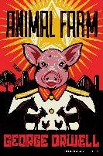

*Songs of Innocence and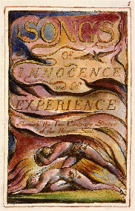 Songs of Experience* by William Blake

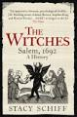*The Witches: 1692 Salem* by Stacey Schiff

**Useful website links:**

[www.freerice.com](http://www.freerice.com) – A UN initiate to help end world hunger, one word   
at a time.

<https://www.bbc.co.uk/bitesize/subjects/z3kw2hv> - A student zone focused on KS3 English skills

**GCSE exam and exam board:**

AQA English Language GCSE

AQA English Literature GCSE

**MATHEMATICS**

Mathematics is a fascinating, enthralling subject that is vital in everything that we do. Fostering a love of learning the subject and appreciating the beauty of Mathematics are key elements that underpin the curriculum at the Suthers School.

The Mathematics curriculum, informed by educational research and exceeding the demands of the National Curriculum, has been carefully crafted and sequenced to be ambitious for all students, no matter of their starting point.

Topics are broken down into small connected and structured steps, each one acting as a building block for the next. Year groups study the ‘story’ of a topic as they progress from one year to the next, with their depth of their knowledge of the story increasing over time.

The first topic students in Year 9 will study is sequences, where students will be developing their knowledge from their Year 7 and 8 story and learning to generate and use quadratic sequences, drawing upon prior knowledge and use of the square numbers. Students then move onto writing and working with numbers in standard form, making cross-curricular links with Science and learning about the reasons why numbers are written in this way and famous real-world examples, such as writing the speed of sound or the diameter of an electron.

The Mathematics curriculum at the Suthers School empowers all students by:

* Stimulating, developing and nurturing the **passion** of all students
* Equipping students with the toolsto become **resilient problem solvers**
* Developing the school wide **character strengths** in every lesson
* Identifying **misconceptions** to anticipate common mistakes and increase understanding for all
* Exploring **historically, current** and **culturally important** Mathematicians and Mathematical events
* Making links to further and **higher education** and **careers**
* Delivering a consistent focus on **real world applications** of Mathematics
* Narrowing the vocabulary gap, by promoting a high level of **oracy**, giving all students the opportunity to **talk like an expert**
* Making **connections** between topics through careful and effective sequencing
* Making **cross curricular** links to other subjects

**Useful website links:**

Corbettmaths.com

Mathsgenie.co.uk

Mrbartonmaths.com

Nrich.maths.org

**GCSE exam and exam board:** OCR GCSE Mathematic

Students will study a range of topics within the domains of biology, chemistry and physics, interleaving ‘working scientifically’ skills throughout.

**SCIENCE**

Our bespoke curriculum builds on the scientific principles learnt during Years 7 & 8, such as the periodic table, energy and reproduction, whilst preparing students for the greater demands of GCSE Science in Year 10.

We deliver the following content in Year 9:

|  |  |  |
| --- | --- | --- |
| **Biology** | **Chemistry** | **Physics** |
| * Diseases | * Particle Model & State Change | * Energy Calculations |
| * Digestive System & enzymes | * Chemical Changes | * Forces, Vectors & Calculations |
| * Variation & Classification | * Atoms & the Periodic Table | * Waves, Sound & Light |

Each carefully chosen topic identifies the most important concepts that will help to further students’ scientific understanding, whilst making contextual links to society and the natural world. Practical activities are meticulously planned to support students’ learning and to encourage the development of investigative skills.

Practice learning tasks are frequently used to support, supplement and extend the learning that takes place in the classroom, whilst encouraging students to be independent thinkers.

**Reading preparation:**

No additional resources are required to access our curriculum. However, if you are keen to expand your horizons and wish to learn more about science, then you might like to try the following publications:

For our curriculum:

* Any ‘CGP KS3 Science’ study guide or workbook is a beneficial learning aid

Just for fun:

* Unlocking the Universe (Stephen & Lucy Hawking)
* Gory Details: Adventures from the Dark Side of Science (Erika Engelhaupt)
* A Short History of Nearly Everything (Bill Bryson)
* What If (Randall Munroe)**Useful online resources:**

**GCSE examination options and exam board:**

All KS4 students study either: AQA GCSE Combined Science: Trilogy (2 GCSEs), or can opt for separate GCSEs in Biology, Chemistry & Physics.

* [Cells Alive!](https://www.cellsalive.com/)
* [Learn Genetics](https://learn.genetics.utah.edu/) (Utah)
* [oPhysics: Interactive Physics Simulations](https://ophysics.com/index.html)
* BBC Bitesize KS3 Science

**PHYSICAL EDUCATION**

Students will participate in a variety of activities this year including… Fitness, Football, Rugby, Netball, Basketball, Gymnastics, Outdoor activity, Hockey, Badminton, Rounders, Cricket, and Athletics

Students will learn rules and regulations for all sports through the exploration of core and advanced skills. These are taught in isolation or in controlled practices. They will use this to gain confidence and an understanding of the sport.

Pupils check their progression against our assessment benchmarks and set targets to improve. They also will learn about health and physical themes which affect physical activity and how they can overcome barriers to be successful. **Current GCSE course:** OCR Cambridge National Sport Studies

**PERSONAL DEVELOPMENT**

Students in Year 9 receive 1 hour of taught PSHE lessons per week. Our programme is shaped according to the principles set out by the PSHE association and all content will link to one of the following themes:

* Health & Wellbeing
* Relationships
* Living in the Wider World

PSHE lessons are a place where students will learn about issues they currently face and those that they may come to face. The PSHE classroom encourages students to reflect on their own opinions and to engage with the opinions of others.

Our Year 9 curriculum builds on the work carried out in Years 7 and 8 and provides a suitable platform for subsequent years.

|  |  |  |  |  |  |
| --- | --- | --- | --- | --- | --- |
| **Unit 1** | **Unit 2** | **Unit 3** | **Unit 4** | **Unit 5** | **Unit 6** |
| **Peer influences**  *Effective communication; Peer influence; Respectful relationships; Gangs* | **Career goals**  *My skills & interests; My future choices; Future goals* | **Respectful relationships**  *Different families; Positive homes; Managing conflict; Living with change* | **Healthy lifestyles**  *Physical health; Mental health; Body image; Making informed health choices* | **Intimate relationships**  *Consent; Intimate relationships; STIs* | **Employability skills**  *Employment rights & responsibilities; Skills for enterprise & employability; My personal ‘brand’* |

In addition, the PSHE curriculum allows students to embrace our TORCH values and understand how these can link into their everyday life.

**HISTORY**

Students will continue their exploration of the 20th century from their Year 8 studies, gaining detailed knowledge and understanding of the complex ways in which changes have impacted, not only the lives of those who experienced them first hand, but also people today. They will explore themes of power, belief, and conflict to compare modern day societies with those from earlier periods they have studied. Students in Year 9 will build on the skills learnt in Year 7 and 8 adding a focus on Narrative and Significance skills.

There are three overarching topic questions in Year 9:

1. **How far is war responsible for the change in politics?** Building on knowledge learnt from other RSS and throughout the history curriculum students will look at the link between politics and war. How war has changed the role of men and women as well as looking at some of the consequences of Cold War.
2. **Who is to blame for the Holocaust?** Students will get a chance to look at the Holocaust from a different viewpoint. Not only looking at the instigators but also the bystanders and those that just complied with it. Students will get a chance to make their own decision on who was to blame for the Holocaust.
3. **How does society change post-WW2?** Looking at the Windrush, Welfare State, Cold War and more modern events that changed society. Students get to map how society has changed concluding to what extent it has changed since WW2.

**Reading preparation:**

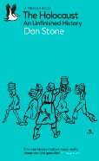Revolutions – A short introduction by Jack A. Goldstone

The Holocaust and unfinished story by Dan Stone

**Useful website links:**

<https://senecalearning.com/en-GB/>

**GCSE Exam and Exam Board:**

Health and the People (AQA)

Elizabethan England (AQA)

Conflict and Tension: Interwar 1919-1939 (AQA

Germany 1890-1945 Democracy and Dictatorship (AQA)

Germany 1890-1945 Democracy and Dictatorship (AQA)

**GEOGRAPHY**

**Year 9 Content Summary:** Student’s physical geography knowledge develops into resource management and economic development. They will consider the conflict between physical, economic and human challenges and opportunities, through a more diverse lens. Students will develop their moral, ethical and environmental judgement on dilemmas facing the world.

Students will study the following units over the year:

* Russia – is the geography of Russia a curse or a benefit to its development?
* UK landscapes – which physical processes have carved the UK landscape?
* Natural resources – how do we use our planet for economic gain?
* Climate change – how is the world responding to the climate emergency?
* Middle East – why has the Middle East developed unevenly?

All units in year 9 will also deliver careers education as part of the curriculum, along with Literacy and Numeracy skills, map skills and oracy.

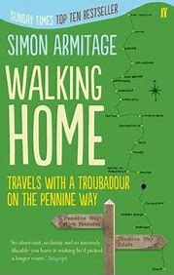**Reading preparation:**

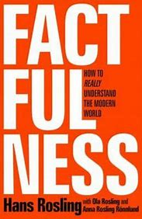Factfulness: Hans Rosling

Prisoners of Geography: Tim Marshall

Walking Home: Simon Armitage

**Useful website links:**

[KS3 Geography - BBC Bitesize](https://www.bbc.co.uk/bitesize/subjects/zrw76sg)

[Russia facts - National Geographic Kids (natgeokids.com)](https://www.natgeokids.com/uk/discover/geography/countries/russia-facts/)

[A Guide to Climate Change for Kids | NASA Climate Kids](https://climatekids.nasa.gov/kids-guide-to-climate-change/)

**GCSE exam and exam board:**

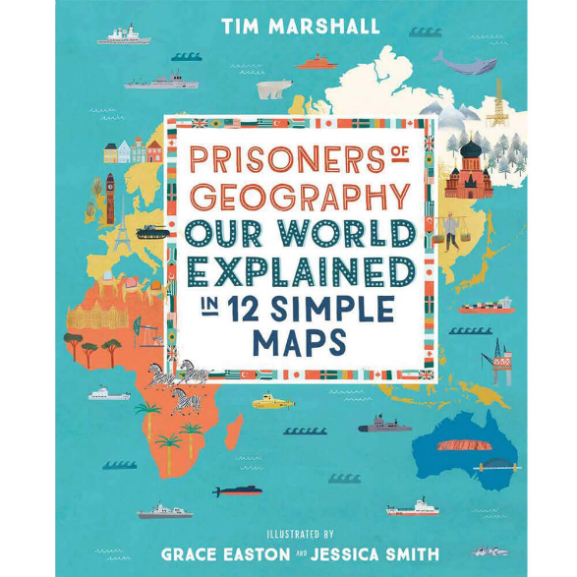AQA Geography



**DESIGN TECHNOLOGY**

**Year 9 Content Summary-** Students will study Hospitality, Catering, graphics, CAD/CAM and product design

Students will complete a range of projects during their second year in Design Technology. Students will complete technology projects that will last predominantly for 9 weeks in duration. We currently deliver the following projects in year 9:

* Lamp project- An introduction to electronics where students design an manufacture an LED desk lamp. The lamp enables students to learn about engineering drawings which then support them to manufacture a range of wood joints. Students also use CAD/ CAM to enhance their product
* Hospitality & Catering- Head chef award. This project enables students to make an informed decision regarding the possibility of taking Hospitality & Catering as an option in year 9. Students help to plan and deliver a catering event
* Christmas project -Introduction to CAD/ CAM to manufacture a Christmas tree decoration
* Engineering Design- a transition project to help students make an informed decision about the possibility of taking Engineering Design as one of their options for year 10. This will be a design and make project incorporating CAD/ CAM, technical drawing and manufacturing.

All projects in year 9 will also deliver careers education as part of the curriculum. Throughout the year students will work towards the following certificates in Design Technology:

|  |  |  |  |
| --- | --- | --- | --- |
|  | **Year 7** | **Year 8** | **Year 9** |
| **Design** | Design apprentice | Product Designer | Engineering apprentice |
| **Food** | Porter and Chef de partie | Sous Chef certificate | Head Chef |
| **Project focus** | H&S and restaurants | Fake aways and takeaways | Careers/ options |
| **Gatsby Bench Marks** | 1,2,4 | 1,2,4,5 | 1,2,4,5 |

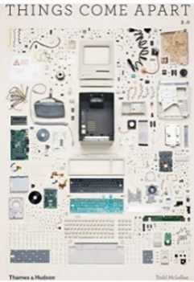**Reading preparation:**

Things come apart 2: A Teardown Manual for Modern Living

Catering Business: How to start, operate and be successful with your own catering company

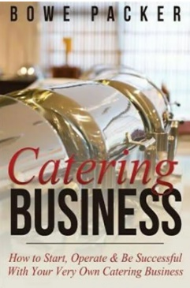**Useful website links:**

Technologystudent.com

BBCgoodfood.com

**GCSE exam and exam board:**

Cambridge National in Engineering Design (OCR)

Cambridge National Hospitality & Catering Level 1&2 (OCR)

In the Computing & Business Department we want to:

**COMPUTING**

"Prepare students for the developing world of work."

We will do this by providing our students with a bespoke curriculum with the intent to teach them a broad range of computer skills that can be implemented in the majority of workplaces.

**Year 9 Content Summary**

In year 9 students will study the following topics:

**9.1 - Excel Quiz (Spreadsheets):** This unit introduces students to Microsoft Excel and teaches them some of the basic formulas and methods of formatting an effective spreadsheet. This is an engaging topic where students will design their interactive quiz on excel. They will need to use a range of formulas, so the quiz is as interactive as possible. As well as this, students will learn how to format a workbook in Excel effectively, so the presentation is as aesthetically pleasing as possible.

**9.2 - Website Design:** In this unit year 9 students will be developing a website about one of their favorite likes or hobbies. Each week they will learn different skills to continuously build their website up from scratch.

**9.3 - Enterprise Project:** This unit intends to build in parts of the Business GCSE & Enterprise & Marketing curriculum students will have the option of choosing in year 10. In this project year 9 students will be carrying out some market research to inform them on designing a new bag for a school student. Following this design, they will then calculate the costs of manufacturing the bag to then set a reasonable selling price. Then they will take this initial design and develop a branding and promotional campaign for it before carrying out a Dragon's Den style pitch. This project is very similar to the coursework they would do if they selected to pick Enterprise and Marketing as one of their options.

**9.4 - Python Programming:** In this unit students will be taught the basics of computer programming using the ‘computer language’ Python. Each lesson will challenge the students to complete more and more complex programming tasks. The skills taught in this topic can be applied to a range of jobs when students eventually leave school and are a crucial part of our curriculum.

**9.5 - Photoshop:** This unit will teach students the basics of Adobe Photoshop. Each lesson will delve into the effectiveness of different tools all leading up to a final project where they combine all they have learnt in one final image.

**9.6 - Scratch:** Scratch is software that teaches students basic coding skills in an engaging way by designing their own games. Each week students will develop a new part of their very game. This unit will finish with them having a fully functioning arcade style video game that they have fully coded themselves.

**SOCIAL STUDIES**

At The Suthers School, we believe that teaching children how to be socially responsible is a vital part of education. During their Social Studies lessons, students will learn about different elements of politics, religion and law that will help prepare them for life in Modern Britain.

**Year 9 Content Summary-**

***Introduction to Philosophy*** In this unit of work we examine some of the early Greek philosophers and look at how ancient philosophy impacts modern society? We also explore Miachiavellian philosophy and challenge the misinterpretation of Nihilism and Existentialism.

***Law, Religion and Morality?*** Students explore the relationship between law and morality, starting by thinking about the role of law. They will learn about different theories of ethics, such as Kantian Ethics and Situation Ethics.

***Understanding Human Rights*** In this unit of work we explore the development of Human Rights, from the Magna Carta to the European Convention of Human Rights and beyond. We will look at the proposed Human Rights Bill and explore how well Human Rights are protected in the UK and in other countries.

***Introduction to the UK Legal System*** In this unit of work, students will learn about the difference between criminal and civil law, how our court systems are structures and the various people who work within the legal system.

***Mock Trail*** Students take on different roles from within the Criminal Justice System. We examine the roles of these people and use that knowledge to prepare for a trial. At the end of the half-term, we carry out a mock trial and decide, innocent or guilty?

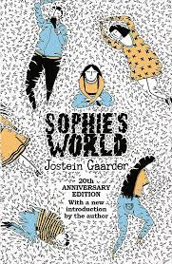

**Reading preparation:**

Sophie’s World by Jostein Gaarder

Law For Beginners from Usborne

**Useful website links:**

Parliament.uk

BBC Bitesize – KS3 Religious Studies

Byc.org.uk (British Youth Council)

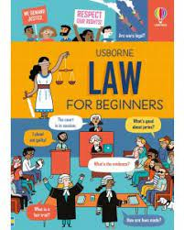

**GCSE exam and exam board:**

This subject prepares students for GCSES in

Citizenship

Philosophy and Ethics

Politics

Religious Studies

**MUSIC**

In music, year 9 students will deepen their understanding and appreciation of a range of musical styles, genres and instruments alongside developing performance skills. Through a largely practical curriculum, students develop their ability to read music using standard notations and perform pieces using keyboards, ukulele, voices and percussion, alongside developing ensemble singing and composition skills.

Year 9 students study the following units:

* **Term 1: Film and Descriptive Music**

Students will focus on how the Elements of Music is used to communicate and emphasise emotion, and how this was used during the Romantic period of music and within film music. Students will develop their understanding of standard notation and performance skills to develop a performance of In The Hall of The Mountain Kind by Grieg, before having the opportunity to compose a piece of film music to a set brief.

* **Term 2: Pop Music Evolution**

This unit focuses of the development of pop music from the 1950s to the present day. Students will analyse, contextualise, and perform pieces from the birth of Rock and Roll in the1950s, through the Beatles, Stevie Wonder, Abba, Oasis and Adele amongst others. In doing so they will develop their understanding of the importance of pop music in contemporary culture whilst building a range of performance skills.

* **Term 3: Cover Versions and Song Writing**

This unit allows students to use the skills and knowledge they have gained since year 7 to develop a range of performance pieces and compositions as solos and ensembles.

**Wider Opportunities in Music**

Alongside their weekly music lesson, students also have the opportunity to undertake individual instrument lessons in a variety of instruments, if you would like to express your interest in your child receiving instrument lessons, please complete the on-line form on the school website. They can also opt to participate in our concerts and performances throughout the year.

**Useful Website links**

<https://www.bbc.co.uk/bitesize>

<https://www.bbc.co.uk/teach/ten-pieces>

Recommended Reading

Turn it Up!: A pitch-perfect history of music that rocked the world by Michaela Weglinski

Our curriculum is designed around up-to-date research on language acquisition. In Year 9 students will continue to acquire new language through listening extensively to model authentic texts. Students will then learn to speak, write and read fluently, using a broadening range of language about their school, their free time and their holidays. Students will become more familiar with the geography and culture of France and the wider French speaking world. They will explore opportunities for travel and work which are provided by having a good knowledge of the French language.

**FRENCH**

In Year 9 students will study the following units:

* ***Ma Routine Quotidienne-*** Students will continue to learn to talk about their daily routine at home e.g. what they do in the morning and how they travel to school. They will also be able to talk about the activities they do after school and what they eat in a typical day. Students will develop their grammatical knowledge by using modal verbs to talk about what they have to do around the house to help.
* ***Mon Collège*** Students will learn to talk about their school, including describing the facilities. They will also practise giving opinions by talking about which subjects they like and don’t like. Students will develop their grammatical knowledge by using comparisons to compare different school subjects.

* ***Mes Loisirs & Le Weekend Dernier*** Students will learn to talk about what they do in their free time. They will talk about their hobbies and passions. Students will also talk about how their hobbies have changed over time. Students will develop their grammatical knowledge by exploring how to use different tenses. In particular, they will be able to talk about what they did last weekend and where they went, using the past perfect tense.

* ***Mes Vacances*** Students will learn to talk about what they do in the school holidays, including travelling in the UK and abroad. Students will also talk about their ideal holidays and where they would go, if they had the choice. Students will develop their grammatical knowledge by learning to use the conditional tense.

Regular cultural capital activities ensure that students also develop an awareness of the culture of France and the wider French speaking world. Throughout Key Stage 3, students are introduced to some well-known and popular cultural films in the target language.

**Reading preparation:** French Grammar for Beginners by Frederic Bibard

**Useful website links**

Duolingo (Website or App)

BBC Bitesize – KS3 French

**GCSE exam and exam board:**

GCSE French - Edexcel

Students begin to master their skills further in year 9, along with exploring new techniques. Year 9’s theme is ‘Make your Mark – The Art of Protest’. This explores how humans make their mark in history and with Art, with a strong focus on how Art has and can be used to protest. Student develop on their knowledge of activists from Year 8, to encompass a wider knowledge of social, historical and political aspects. This gives students the opportunity to make connections and express their opinion on work as well as seeing correlations throughout history and art produced in similar times. Year 9 has a large focus on Art history which is explored through artists and art movements.

**ART**

Students will develop and learn the following:

* The origin of Art
* Pigment and brush creation
* Drawing techniques
* Print making ( various techniques)
* Stencilling
* Collaboration
* Acrylic painting
* Photoshop
* Facial guidelines
* Chalk Art
* Typography focusing on graffiti
* Mixed media

This theme exploration will allow students to delve deeper into their understanding of what Art can be through artists, art movements and practical skills, gaining a greater appreciation and equipping them with the ability to discuss and create work based on a particular aspect of society. Giving them knowledge and skills to aid them in answering our overarching questions, how can Art be influenced by social, historical and political factors? Is Art a form of protest?

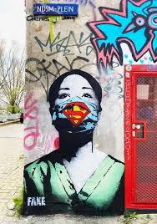Artists and movements that we explore throughout the year are both classical ones and contemporary to give them a breadth of knowledge to aid them in the Art world, they range from Henri Matisse, Fauvism to street artist Fake and the Chalk Riot.

**GCSE exam and exam board:**



**GCSE Art and Design, Fine Art**

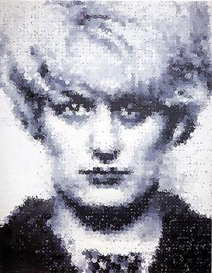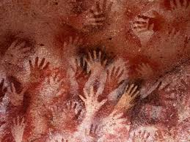 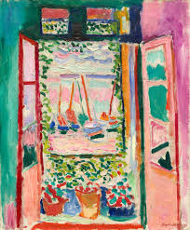

Part of the academic year students have the opportunity to extend their learning and passion for art through the Art Challenges. These Art Challenges are half termly and develop on the learning, subject matter and skills they have been exploring in class. Students are required to complete at least three of the six challenges within the year, of their choosing

**DRAMA**

The focus in Drama for Year 9 students is to stretch and challenge pre-existing learnt skills. Students will learn about past and present theatre practitioners and how their style and techniques can be used to create original performance work. They will watch live theatre to analyse and evaluate the design aspects and apply what they learn to their performance work.

**Key topics in Year 9:**

|  |  |  |  |  |  |
| --- | --- | --- | --- | --- | --- |
| **Autumn 1** | **Autumn 2** | **Spring 1** | **Spring 2** | **Summer 1** | **Summer 2** |
| John Godber- Teacher’s | | Craig and Bentley | Exploring a Script | Screen Acting | A Monster Calls |

* Wider Opportunities in Drama
* LAMDA Qualification in Acting, Musical Theatre, Public Speaking and more…
* S29 Youth Theatre Club for KS3
* A musical theatre production.
* Many other shows throughout the year!
* GCSE Exam Board



