



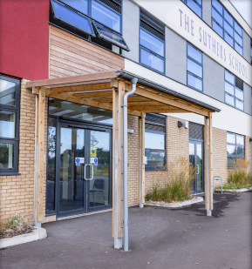

**YEAR 8 CURRICULUM**

**2024/2025**

**INTRODUCTION FROM MISS WATKIN: HEAD TEACHER**

Dear Parents & Carers,

The Suthers School promises to deliver a highly academic curriculum and to empower the young people of Newark to do more than they ever thought possible. During your time here at The Suthers School, you will learn how to become the best version of yourself, by committing to your studies and taking part in all the opportunities you are faced with, grasping them in both hands.

We offer a curriculum that meets the needs of all students, providing exciting enrichment opportunities which guarantees access to a wealth of extra-curricular activities and student leadership responsibilities.

**Nic Watkin**

Head Teacher

We were incredibly proud to celebrate our third set of GCSE results this summer. There were some incredible individual performances and all students have gone on to secure their chosen pathway at Post-16. Academic performance, along with a commitment to character development, is a key focus for all students at The Suthers School.

**2024 RESULTS**

**THE SUTHERS WAY**

The Suthers School is a calm, safe, purposeful, and positive place to learn. Our aim is for all lessons to be free from disruption. The behaviour system is designed to provide a consistent approach across all lessons and to prevent persistent low-level disruption. Teachers will at all points aim to use positive framing to support their approach, but our ambitious standards must be adhered to.

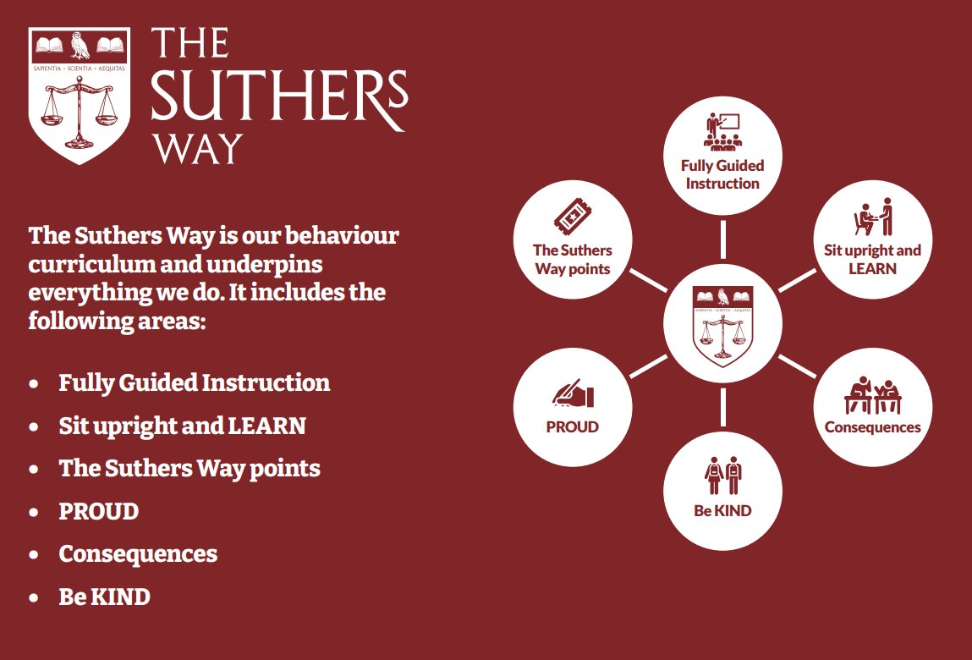

**EXTRA CURRICULAR & ENRICHMENT**

We know that young people need both a strong academic foundation and well-developed character strengths to succeed in education and the world beyond. That’s why we are committed to delivering an extensive enrichment programme—and through our extended school day we are able to guarantee participation for all, no matter what their starting point.

Our extended curriculum provides all pupils with guaranteed access to an exciting range of activities; from German language lessons and computer programming to creative arts, sport, leadership, charity work, sports clubs and running a student newsletter- students at The Suthers School benefit from a truly enriching curriculum.

Our current Enrichment provision is as follows:

|  |  |  |
| --- | --- | --- |
| Tuesday | Wednesday | Thursday |
| The Suthers Collective Orchestra**  Boxing  Warhammer Club | Arts Awards TBC  Cooking Club  S29 Drama Club TBC  Netball (PE Department)  Football (PE Department) | Gardening Club  Musical Productions Rehearsal*  Shakespeare Club  Remembrance Club  Boxing  Boys Rugby (PE Department)  Girls Rugby (PE Department) |
| *Please note that participation in the school performance will be via audition. For more information, please contact Mr. Case.  ** Please note this club is for instrumentalists only. | | |

**THE FERN & LITERACY STRATEGY**

At The Suthers School we take pride in developing literacy skills across all subject areas and promote reading, writing and oracy with effective whole school strategies. We value the importance of developing the key skills of literacy within our students to enable them to fully access the broad and diverse curriculum on offer and to foster articulate individuals who are able to navigate the learning world around them. Some of our whole school strategies include…

* **Yellow Highlighters**: All staff wear their yellow highlighters with pride and use these to give live feedback to students on literacy errors and misconceptions in their writing. Students are taught to edit and respond in red pen to ensure standards remain high.  Students will also be guided during their lessons to use their yellow highlighters during self and peer assessment opportunities.
* **SHAPE**: All classrooms develop oracy through our acronym to remind students of how to SHAPE answers in their lessons. This is supported by our ‘no hands up’ policy in class to allow teachers to target questions and ensure that all learners are challenged appropriately so they are contributing and learning at their level
* **Literacy Leaders**: Our older students in school are training to become our literacy leaders to support students in Y7 with their reading during form time each week. We have scope for this to progress into a mentoring scheme to support writing too.
* **Develop Brilliant Reading:** Students will take part in the Develop Brilliant Reading programme throughout the year which are low stakes / informal reading tests to practice the skills they have accumulated each term. This will enable students to become more aware of their reading ages and focus on specific areas for improvement.

The Fern is our library, learning and careers hub at The Suthers School, aptly named after our location in Fernwood and in line with our TORCH tree emblem. We use the motto ‘Learn at The Fern’ as we have dedicated space for students to read, study and research. Students are able to access The Fern in their lunchtimes and during enrichment sessions. KS3 English lessons also take place in The Fern once per week to support all curriculum areas in reading and writing. Students complete various activities and tasks to improve their skills in fluency, comprehension, phonics and oracy which can be utilised in all lessons. We host events and rewards trips throughout the year for both students and parents and carers in The Fern including book stalls and workshops to support parents and carers with how to develop reading for pleasure at home. We also provide students with an opportunity to engage with competitions and reading-related events throughout the year, as well as exposing them to author talks and community events.

Library lesson focuses:

* DEAR text activities – Noughts and Crosses
* Reading comprehension
* Grammar
* Guided reading

**ENGLISH**

Students will continue to study high quality texts to develop and deepen their knowledge of a breadth of current and historical contexts, with a focus on writers and readers’ responses, perspectives and interpretations through time. They will deepen their appreciation of how language, in literature, in performance and in society, shapes meaning and our perceptions of it, through the work of others and their own. Students will begin to apply critical lenses to the intentions of writing and develop their understanding of how it may be received.

**Our Year 8 Long Term Plan:**

* **Half Term One**: *Literature of Protest* (exploring a myriad of Protest Literature throughout history).
* **Half Term Two**: *Language of Protest -* An in-depth interrogation of the intentions behind non-fiction writing.
* **Half Term Three**: *The Woman in Black* by Susan Hill
* **Half term Four**: *The Woman in Black* by Susan Hill
* **Half Term Five**: *Romeo and Juliet* by William Shakespeare
* 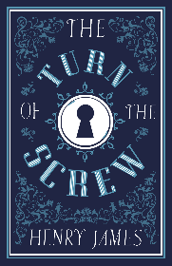**Half Term Six:** *Romeo and Juliet* by William Shakespeare

**Reading preparation:**

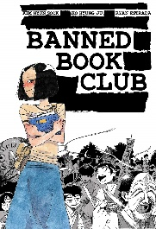*The Turn of the Screw* by Henry James

*Banned Book* Club by Kim Hyun Sook

*We Were Liars* by E Lockhart

**Useful website links:**

[www.freerice.com](http://www.freerice.com) – A UN initiate to help end world hunger, one word   
at a time.

<https://www.rsc.org.uk/shakespeare-learning-zone> - A student dedicated   
learning zone for all things ‘Shakespeare’.

**GCSE exam and exam board:**

AQA English Language GCSE

AQA English Literature GCSE

**MATHEMATICS**

Mathematics is a fascinating, enthralling subject that is vital in everything that we do. Fostering a love of learning the subject and appreciating the beauty of Mathematics are key elements that underpin the curriculum at the Suthers School.

The Mathematics curriculum, informed by educational research and exceeding the demands of the National Curriculum, has been carefully crafted and sequenced to be ambitious for all students, no matter of their starting point.

Topics are broken down into small connected and structured steps, each one acting as a building block for the next. Year groups study the ‘story’ of a topic as they progress from one year to the next, with their depth of their knowledge of the story increasing over time.

The first topic students in Year 8 will study is sequences, where students will be developing their knowledge from their Year 7 story and learning to describe linear numerical sequences algebraically. Students then move onto developing their knowledge of prime numbers, factors and multiples, and being able to pick out key information from worded real-world contexts.

The Mathematics curriculum at the Suthers School empowers all students by:

* Stimulating, developing and nurturing the **passion** of all students
* Equipping students with the toolsto become **resilient problem solvers**
* Developing the school wide **character strengths** in every lesson
* Identifying **misconceptions** to anticipate common mistakes and increase understanding for all
* Exploring **historically, current** and **culturally important** Mathematicians and Mathematical events
* Making links to further and **higher education** and **careers**
* Delivering a consistent focus on **real world applications** of Mathematics
* Narrowing the vocabulary gap, by promoting a high level of **oracy**, giving all students the opportunity to **talk like an expert**
* Making **connections** between topics through careful and effective sequencing
* Making **cross curricular** links to other subjects

**Useful website links:**

Corbettmaths.com

Mathsgenie.co.uk

Mrbartonmaths.com

Nrich.maths.org

**GCSE exam and exam board:**

OCR GCSE Mathematics

**SCIENCE**

Students will study a range of topics within the domains of biology, chemistry and physics, interleaving ‘working scientifically’ skills throughout.

Our bespoke curriculum builds on the scientific principles learnt during Year 7, such as the particle model, forces and reproduction.

We deliver the following content in Year 8:

|  |  |  |
| --- | --- | --- |
| **Biology** | **Chemistry** | **Physics** |
| * Plants | * Separation Techniques | * Energy, Heat & Particles |
| * Respiratory System | * The Periodic Table | * Electromagnetism |
| * Circulatory System | * Earth’s Resources | * Forces & Motion |

Each carefully chosen topic identifies the most important concepts that will help to further students’ scientific understanding, whilst making contextual links to society and the natural world. Practical activities are meticulously planned to support students’ learning and to encourage the development of investigative skills.

Practice learning tasks are frequently used to support, supplement and extend the learning that takes place in the classroom, whilst encouraging students to be independent thinkers.

**Reading preparation:**

No additional resources are required to access our curriculum. However, if you are keen to expand your horizons and wish to learn more about science, then you might like to try the following publications:

For our curriculum:

* Any ‘CGP KS3 Science’ study guide or workbook is a beneficial learning aid

Just for fun:

* On the Origin of Species (Sabena Radeva)
* I Am a Book. I Am a Portal to the Universe (Stefanie Posavec & Miriam Quick)
* Diary of a Young Naturalist (Dara McAnulty)
* The Disappearing Spoon, Young Readers Edition (Sam Kean)

**Useful online resources:**

**GCSE examination options and exam board:**

All KS4 students study either: AQA GCSE Combined Science: Trilogy (2 GCSEs), or can opt for separate GCSEs in Biology, Chemistry & Physics.

* [Royal Society of Chemistry: Periodic Table](https://www.rsc.org/periodic-table)
* [PhET Colorado: Circuit Construction Kit](https://phet.colorado.edu/sims/html/circuit-construction-kit-dc/latest/circuit-construction-kit-dc_en.html)
* BBC Bitesize KS3 Science

**PHYSICAL EDUCATION**

Students will participate in a variety of activities this year including… Fitness, Football, Rugby, Netball, Basketball, Gymnastics, Outdoor activity, Hockey, Badminton, Rounders, Cricket, and Athletics

Students will learn rules and regulations for all sports through the exploration of core and advanced skills. These are taught in isolation or in controlled practices. They will use this to gain confidence and an understanding of the sport.

Pupils check their progression against our assessment benchmarks and set targets to improve. They also will learn about health and physical themes which affect physical activity and how they can overcome barriers to be successful.

**Current GCSE course:**

OCR Cambridge National Sport Studies

**PERSONAL DEVELOPMENT**

Students in Year 8 receive 1 hour of taught PSHE lessons per week. Our programme is shaped according to the principles set out by the PSHE association and all content will link to one of the following themes:

* Health & Wellbeing
* Relationships
* Living in the Wider World

PSHE lessons are a place where students will learn about issues they currently face and those that they may come to face. The PSHE classroom encourages students to reflect on their own opinions and to engage with the opinions of others.

Our Year 8 curriculum builds on the work carried out in Year 7 and provides a suitable platform for subsequent years.

In addition, the PSHE curriculum allows students to embrace our TORCH values and understand how these can link into their everyday life.

|  |  |  |  |  |  |  |
| --- | --- | --- | --- | --- | --- | --- |
|  | **Unit 1** | **Unit 2** | **Unit 3** | **Unit 4** | **Unit 5** | **Unit 6** |
| **8** | **Substance use**  *Understanding caffeine; Smoking; Vaping; Alcohol* | **Community & careers**  *My community; Local employment; Career goals* | **Discrimination**  *Forms of discrimination; Protected characteristics; Equality & equity* | **Emotional wellbeing**  *My emotional health; Promoting wellbeing; Digital resilience* | **Identity & relationships**  *Healthy relationships; consent* | **Digital literacy**  *Online communication; Online risks; Gambling; Trust in a digital age* |

We are also responsive to any identified issues which we may come across within our school community and will therefore adapt the curriculum when appropriate.

**HISTORY**

Students will examine the impact of industrialisation, imperialism, and slavery on Britain and beyond, comparing the experiences of different nations and their peoples. They will develop an understanding of the growth of popular protest and its role in challenging and changing the status quo and, in doing so, make links to modern day movements. They will begin to explore events of the 20th century and their far-reaching consequences. Students in Year 8 will build on the skills learnt in Year 7 adding a focus on Interpretations and Judgement skills.

There are three overarching topic questions in Year 8:

1. **How far has the British Empire created modern Britain?**  This topic will delve into what an Empire is, with students coming to their own conclusions about whether industrialisation, slavery and the British empire were all needed for their individual growth.
2. **Where are the silences in historiography for WW1?** Students get the chance to look at a different side of WW1. Looking at the developments made through medicine, technology, and science due to WW1, the role music played and how life changed for many due to WW1. Alongside this, students will also investigate why soldiers did not speak about the war when they came home, linking to the rest of Year 8 students will also look at how the empire influenced soldiers.
3. **Why does the Empire decline?**  Students will investigate where the British Empire is in 1918, decolonisation and the legacy of the British Empire.

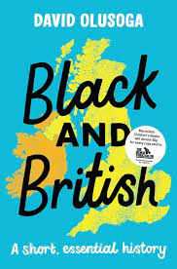**Reading preparation:**

Black and British: A Forgotten History by David Olusoga

Death in Ten Minutes: Kitty Marion. Activist. Arsonist. Suffragette. By Fern Riddell

**Useful website links:**

**GCSE Exam and Exam Board:**

Health and the People (AQA)

Elizabethan England (AQA)

Conflict and Tension: Interwar 1919-1939 (AQA)

Germany 1890-1945 Democracy and Dictatorship (AQA)

**GEOGRAPHY**

Students will deepen their knowledge of physical geography and extend their awareness of human geography through both historic and current lenses. They will learn to carefully consider the challenges and opportunities faced by current global development. This will underpin an increasing personal sense of environmental responsibility.

Students will study the following units over the year:

* Rivers – Human & physical importance of rivers.
* Sustainability – provide the knowledge and skills to address environmental challenges and make informed decisions for a more sustainable future.
* Development – understand global inequalities and the factors that influence economic and social progress, fostering awareness and empathy for diverse communities.
* Tectonics – describe the forces that shape our planet, leading to natural disasters like earthquakes and volcanoes, and comprehend the impact on human societies.
* Migration – develop an understanding of the complex social, economic, and political factors driving human movement and its impact on cultures and communities worldwide.
* Uganda – provide an insight into a diverse country's geography, culture, and development challenges, fostering global awareness and understanding.

All units in year 8 will also deliver careers education as part of the curriculum, along with literacy and numeracy skills, map skills and oracy.

**Reading preparation:**

Trash: Andy Mulligan

Gorilla Dawn: Gill Lewis

No one is too small to make a difference: Greta Thunberg

**Useful website links:**

[KS3 Geography - BBC Bitesize](https://www.bbc.co.uk/bitesize/subjects/zrw76sg)

[Volcano facts | National Geographic Kids (natgeokids.com)](https://www.natgeokids.com/uk/discover/geography/physical-geography/volcano-facts/)

[Gapminder Tools](https://www.gapminder.org/tools/#$chart-type=bubbles&url=v1)

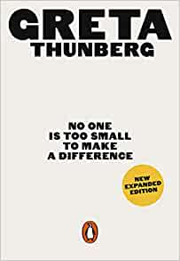

**GCSE exam and exam board:**

AQA Geography



**DESIGN TECHNOLOGY**

Students will study Hospitality, Catering, graphics, CAD/CAM and product design.

Students will complete a range of projects during their second year in Design Technology. Students will complete technology projects that will last predominantly for 9 weeks in duration. We currently deliver the following projects in year 8:

* Pewter project & Sweet dispenser- an introduction to wood joints, materials and CAD/ CAM (laser cutting)
* Cooking for Health- students study a variety of dishes and focus on how healthy . This project also looks at the hospitality and catering industry and their career paths
* Christmas project -Introduction to CAD/ CAM to manufacture a Christmas tree decoration
* Graphics -An introduction to basic technical drawing skills, Computer Aided Design and rendering using FUSION 360 software

All projects in year 8 will also deliver careers education as part of the curriculum. Throughout the year students will work towards the following certificates in Design Technology:

|  |  |  |  |
| --- | --- | --- | --- |
|  | **Year 7** | **Year 8** | **Year 9** |
| **Design** | Design apprentice | Product Designer | Engineering apprentice |
| **Food** | Porter and Chef de partie | Sous Chef certificate | Head Chef |
| **Project focus** | Goo Kitchen Practices | Cooking for Health | Fake aways and takeaways |
| **Gatsby Bench Marks** | 1,2,4 | 1,2,4,5 | 1,2,4,5 |

**Reading preparation:**

Digital model making: Laser cutting, 3D Printing and reverse engineering (Helen Lansdowne)

The Design of Everyday Things- Don Norman

Food Anatomy: The curious parts & pieces of our edible world Julia Rothman

**Useful website links:**

Technologystudent.com

BBCgoodfood.com

**GCSE exam and exam board:**

Cambridge National in Engineering Design (OCR)

Cambridge National Hospitality & Catering Level 1&2 (OCR)

In the Computing & Business Department we want to:

**COMPUTING**

"Prepare students for the developing world of work."

We will do this by providing our students with a bespoke curriculum with the intent to teach them a broad range of computer skills that can be implemented in the majority of workplaces.

In year 8 students will study the following topics:

**8.1 - Digital Citizenship:** This unit aims to educate students on how to be responsible, safe, and ethical users of technology and digital media. The unit will cover topics such as online privacy, cyberbullying, responsible social media use, and critical thinking when consuming online content. Students will learn how to identify fake news and propaganda, how to protect their personal information online, and how to maintain a positive digital footprint. Additionally, students will learn about digital rights and responsibilities, and how to be good digital citizens in a global context.

**8.2 - Theme Park Spreadsheets:** This unit introduces students to Microsoft Excel and teaches them some of the basic formulas and methods of formatting an effective spreadsheet. This is an engaging topic where students will design their own theme park on Excel and then calculate how much revenue and profit, they will generate over a year.

**8.3 - Python Programming:** In this unit students will be taught the basics of computer programming using the ‘computer language’ Python. Each lesson will challenge the students to complete more and more complex programming tasks. The skills taught in this topic can be applied to a range of jobs when students eventually leave school and are a crucial part of our curriculum.

**8.4 - Enterprise Project:** This unit intends to build in parts of the Business GCSE & Enterprise & Marketing curriculum students will have the option of choosing in year 10. This project will extend over two years as what students complete in this project continues into the 9.4 topic. In year 8 students will be carrying out some market research to inform them on designing a new bag for a school student. Following this design, they will then calculate the costs of manufacturing the bag to then set a reasonable selling price. Then in year 9 they will take this initial design and develop a branding and promotional campaign for it.

**8.5 - Photoshop:** This unit will teach students the basics of Adobe Photoshop. Each lesson will delve into the effectiveness of different tools all leading up to a final project where they combine all they have learnt in one final image.

**8.6 - Scratch:** Scratch is software that teaches students basic coding skills in an engaging way by designing their own games. Each lesson students will be tasked to create the code for a different ‘classic’ game like Pacman. They will learn different skills each week leading to them designing their own game when they get to year 9.

**RELIGIOUS & SOCIAL STUDIES**

At The Suthers School, we believe in teaching children how to be socially responsible. During their Religious and Social Studies lessons, students will learn about different elements of politics, religion, society and law that will help prepare them for life in Modern Britain.

How has religion shaped the UK and UK Democracy?  In this unit of work, we examine the democratic institutions of the UK, exploring the role of government and parliament. Students will also learn about the importance of democracy. We will look at how UK Democracy has developed and strengthened over time. We will also look at how religion and other factors influence democracy in the UK.

Religion in the media and media literacy Students will explore the role that media plays in today’s society, with a focus on religion and religious stereotypes. We will also explore the changing nature of the media with a focus on social media, identifying misinformation and false news stories.

How has religion influenced our laws?  Students will start by examining the influence of The Bible on UK law. We then explore the three main sources of law. We then examine in detail the process of parliamentary law making and the concept of Parliamentary Supremacy.

Moral Decision-Making Students will explore the question of right and wrong. We will also look at how morals can influence our decision making. We will think about the link between religion and morality and explore the question of morality in an increasingly secular society.

Religion and Democracy – A Global Perspective In this unit of work, we will explore religion, democracy and society in a range of global contexts.



**Reading preparation:**

All About Politics by Andrew Marr

**Useful website links:**

Parliament.uk

BBC Bitesize – KS3 Religious Studies

Byc.org.uk (British Youth Council)

**GCSE exam and exam board:**

This subject prepares students for GCSES in

Citizenship, Philosophy and Ethics, Politics, Religious Studies

**ART**

Students in year 8 will continue their Art journey focusing on the theme ‘Tales beneath the waves’, building on their previous knowledge and skills learnt in year 7. As part of this topic students will explore the impact of plastic pollution on our seas and how myths and legends have developed over time with a focus on oceanic tales, such as mermaids and the kraken.

Students will develop and learn the following –

* Drawing techniques
* Acrylic and watercolor painting
* Soft pastels
* Working to a brief
* Sculpture in clay and paper
* Paper manipulation
* Scientific illustration
* Typography
* Photography
* Contextualisation

Combining these with the study of artists, their context and styles, students begin to develop their appreciation of wider works of art and art movements. Giving them knowledge and skills to aid them in answering our overarching question, how can Art be influenced by science and literature?

Part of the academic year students have the opportunity to extend their learning and passion for art through the Art Challenges. These Art Challenges are half termly and develop on the learning, subject matter and skills they have been exploring in class. Students are required to complete at least three of the six challenges within the year, of their choosing.

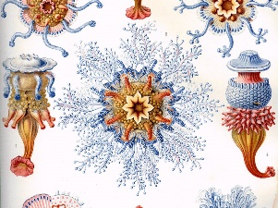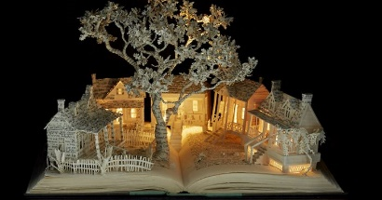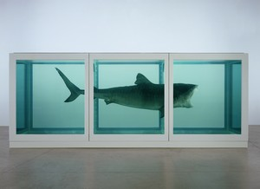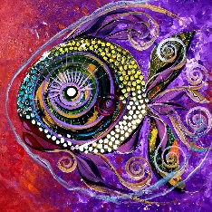Artists that we explore throughout the year are both classic and contemporary such as Vincent Van Gogh, J Vincent Scarpace, Damien Hirst, Su Blackwell, Ernst Haeckel along with many more.

**Workshops and trips**

**GCSE exam and exam board:**



**GCSE Art and Design, Fine Art**

In the department we aim for students to gain enriched knowledge of the world around them and how this can give contextualisation to the work we do and view in the classroom. This year we would like to provide students with a talk from a visiting scientific illustrator, a workshop from Lush and a trip to The Deep.

**Reading suggestions:**

* Gender swapped fairy Tales by Karrie Fransman and Jonathan Plackett
* The story of painting: How Art was made – DK
* Blue Planet II: A New World of Hidden Depths - James Honeyborne & Mark Brownlo

**MUSIC**

In music, year 8 students will deepen their understanding and appreciation of a range of musical styles, genres and instruments alongside developing performance skills. Through a largely practical curriculum, students will develop their ability to read music using standard notations and perform pieces using keyboards, ukulele and percussion, alongside developing ensemble singing and composition skills.

In year 8, students will study the following units:

**Term 1: Variations**

This unit focuses on how the Musical Elements are used and manipulated to develop compositions and variations. In the completion of this unit, students will develop compositions based on standard chord progressions that demonstration their understand of the Elements. They will then focus on learning how this was done during the Baroque Period through an ensemble performance of Canon in D by Pachelbel.

**Term 2: Blues and Jazz**

Students will learn about the origins and cultural significance of blues and jazz and its influence in popular music. Students will develop performance skills by learning the 12-bar blues, walking bass, extended chords, jazz melodies and improvisation.

**Term 3: Music Production and Composition**

In this unit students will develop composition skills through computer music production. They will use BandLab to explore musical structures, textures, contrast, and development. They will use a variety of music production skills including sampling, MIDI sequencing, mixing, and the use of effects.

Wider Opportunities in Music

Alongside their weekly music lesson, students also have the opportunity to undertake individual instrument lessons in a variety of instruments, if you would like to express your interest in your child receiving instrument lessons, please complete the on-line form on the school website. They can also opt to participate in our concerts and performances throughout the year.

* Useful Website links

<https://www.bbc.co.uk/bitesize>

<https://www.bbc.co.uk/teach/ten-pieces>

* Recommended Reading

Turn it Up!: A pitch-perfect history of music that rocked the world by Michaela Weglinski

**FRENCH**

Our curriculum is designed around up-to-date research on language acquisition. In Year 8, students will continue to acquire new language through listening extensively to model authentic texts. Students will then learn to speak, write and read fluently, using a broadening range of language (1000 words approx.), about where they live, their daily routine at home and their school. Students will become familiar with the geography and culture of France and the wider French speaking world. They will explore opportunities for travel and work provided by a good knowledge of French.

In Year 8 students will study the following units:-

* ***Ma Ville-*** Students will learn to describe their hometown, including the facilities and amenities. They will also talk about what they do in their towns. Students will develop their grammatical knowledge by using infinitive structures, such as talking about what they like to do, and what they can do in their town. Students will build on expressing and justifying their opinions.
* ***Ma Routine Quotidienne-*** Students will learn to talk about their daily routine at home e.g. what they do in the morning and how they travel to school. They will also be able to talk about the activities they do after school and what they eat in a typical day. Students will develop their grammatical knowledge by using modal verbs to talk about what they have to do around the house to help.
* ***Mon Collège-*** Students will learn to talk about their school, including describing the facilities. They will also practise giving more opinions by talking about which subjects they like and don’t like with justifications. Students will develop their grammatical knowledge by using comparisons to compare different school subjects and will be able to give more complex opinions than in previous topics.

Regular cultural capital activities ensure that students also develop an awareness of the culture of France and the wider French speaking world. Throughout Key Stage 3, students are also introduced to some well-known and popular cultural films in the target language.

**Reading preparation:**

My First 1000 French Words by Sam Hutchinson

France: Travel for Kids by Dinobibi Publishing

**Useful website links:**

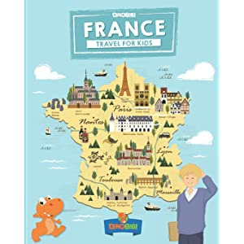

Duolingo (Website or App)

BBC Bitesize – KS3 French

**GCSE exam and exam board:**

GCSE French - Edexcel

**DRAMA**

The year 8 curriculum aims to ensure that all pupils acquire a wide awareness of drama vocabulary and a strong understanding of both group work and individual performance requirements. A large part of the course focuses on an awareness of vocal and physical skills and of non-verbal communication, as well as analytical and evaluative skills. The Drama curriculum works through sequenced learning: introducing, exploring and embedding key elements of drama.

**Key topics in Year 8:**

|  |  |  |  |  |  |
| --- | --- | --- | --- | --- | --- |
| **Autumn 1** | **Autumn 2** | **Spring 1** | **Spring 2** | **Summer 1** | **Summer 2** |
| Willy Russell’s *Our Day Out* | | The Island | Theatre-in-Education | Curious Incident | Treasure Island |

* Wider Opportunities in Drama
* LAMDA Qualification in Acting, Musical Theatre, Public Speaking and more…
* S29 Youth Theatre Club for KS3
* A musical theatre production.
* Many other shows throughout the year!
* GCSE Exam Board



