Mathematics Schedule
KS3
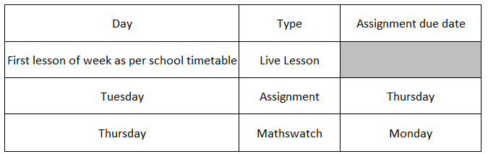

KS4
