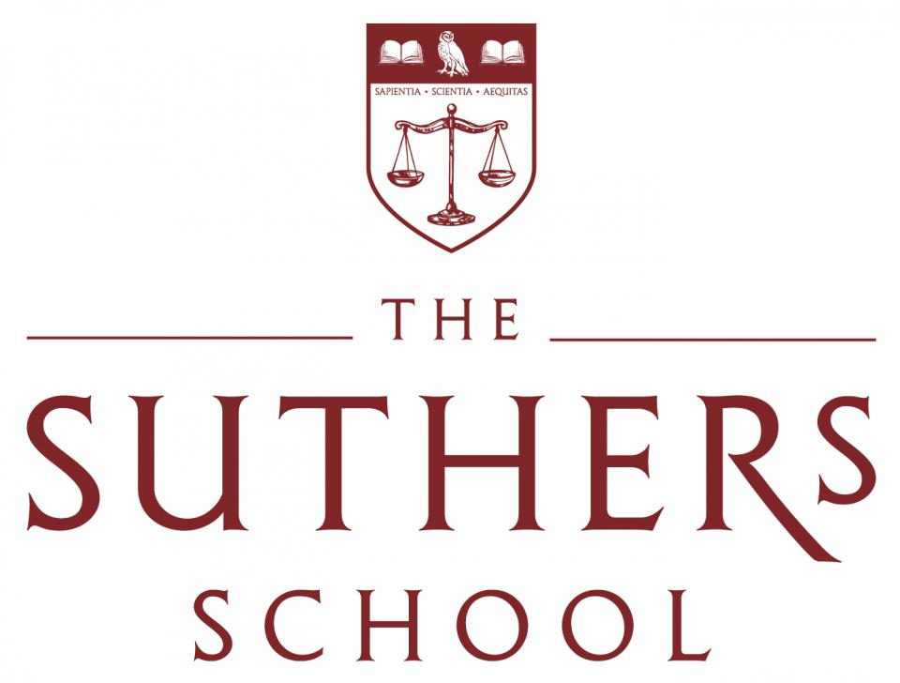
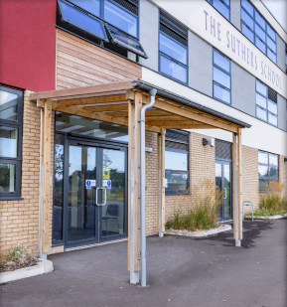
YEAR 9 CURRICULUM

INTRODUCTION FROM MRS WATKIN: HEAD TEACHER

Dear Parents/ Carers,
There is no doubt that, as a brand-new school, The Suthers School is in an enviable position—able to craft a curriculum that meets the needs of all students, providing exciting enrichment opportunities which guarantees access to a wealth of extra-curricular activities and student leadership responsibilities.
The Suthers School promises to deliver a highly academic curriculum and to empower the young people of Newark to do more than they ever thought possible. Over the next few years at The Suthers School, you will learn how to become the best version of yourself, by committing to your studies and taking part in all the opportunities you are faced with and grasping them in both hands.

Nic Watkin
Head Teacher

2022 RESULTS
We were incredibly proud to celebrate our first ever set of GCSE results this summer. There were some incredible individual performances and all students have gone on to secure their chosen pathway at Post-16. Academic performance, along with a commitment to character development, is a key focus for all students at The Suthers School.
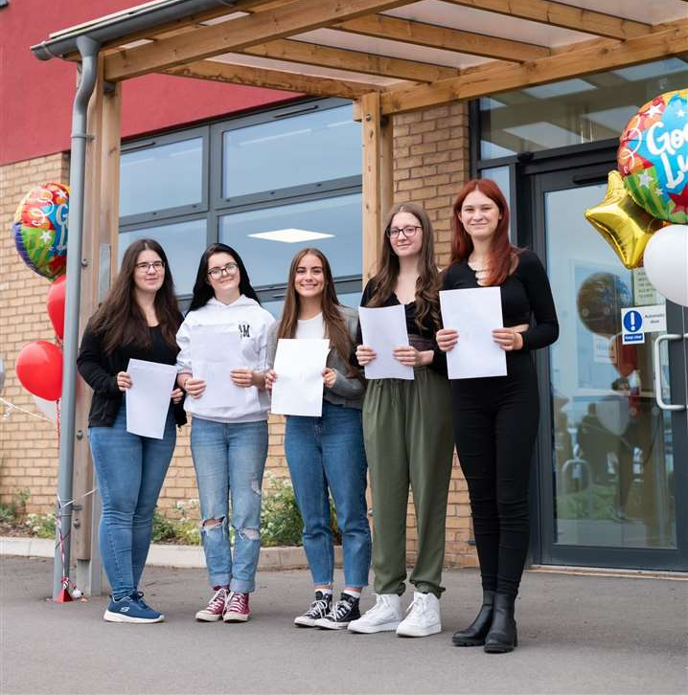
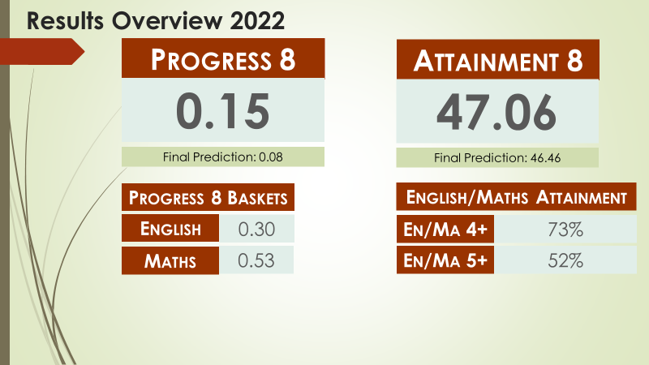

CULTURE FOR LEARNING

The Suthers School is a calm, safe, purposeful, and positive place to learn. Our aim is for all lessons to be free from disruption. The behaviour system is designed to provide a consistent approach across all lessons and to prevent persistent low-level disruption. Teachers will at all points aim to use positive framing to support their approach, but our ambitious standards must be adhered to.
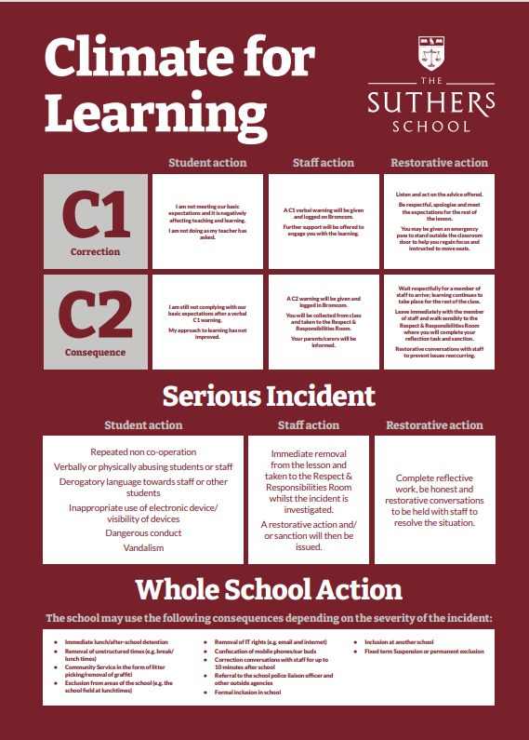
EXTRA CURRICULAR & ENRICHMENT
We know that young people need both a strong academic foundation and well-developed character strengths to succeed in education and the world beyond. That’s why we are committed to delivering an extensive enrichment programme—and through our extended school day we are able to guarantee participation for all, no matter what their starting point.
Our extended curriculum provides all pupils with guaranteed access to an exciting range of activities; from German language lessons and computer programming to creative arts, sport, leadership, charity work, sports clubs and running a student newsletter- students at The Suthers School benefit from a truly enriching curriculum.
Our current Enrichment provision is as follows:
Tuesday 2:55pm – 4pm | Enrichment for all (All students take part in an enrichment activity of their choice)
Wednesday 2:55pm -4pm | Study Hall (students have the option of signing up for additional time for Practice Learning, where access is provided to IT rooms and to teachers for support with their learning where necessary).
Thursday 2:55pm -4pm | Optional Enrichment (Students may opt in to a range of enrichment activities).
Friday 2:55pm -4pm

Whole School Enrichment Activities: -
The enrichment activities currently on offer on a Tuesday are:
Amnesty Club | Chess | Girls Football | Strategy Board Games
Apps for Good | Choir | Journalism | Study Room
Baking | The Fern Club | Netball | Typography
Basketball | Cricket | Rugby | Young Enterprise
Boxing | German | STEM

Whole School Enrichment Activities: -
At present, the following activities are available on a Thursday/Friday after school
Netball
Football
Rugby
Baking
Photography
Dance

THE FERN & LITERACY STRATEGY
Literacy at The Suthers School

At The Suthers School we take pride in developing literacy skills across all subject areas and promote reading, writing and oracy with effective whole school strategies. We value the importance of developing the key skills of literacy within our students to enable them to fully access the broad and diverse curriculum on offer and to foster articulate individuals who are able to navigate the learning world around them. Some of our whole school strategies include…

- DEAR (Drop Everything And Read): dedicated daily time to pause curriculum learning and promote reading for pleasure through listening to a story being read aloud by class teachers.
- Yellow Highlighters: all staff wear their yellow highlighters with pride and use these to give live feedback to students on literacy errors and misconceptions in their writing. Students are taught to edit and respond in red pen to ensure standards remain high.
- Vocabulary learning letters: students receive a half-termly poster containing five key words for every subject they study. This forms part of our Practice Learning (homework) strategy in which, students are directed to carry out an activity to help them learn, spell and understand the key term that is crucial to their curriculum learning that half term. This is celebrated through an optional spelling bee, broadcast during form time, to celebrate those students who excel in this area.
- Word of the week: through our form time programme, students learn a word of the week, designed to teach a concept throughout the year and promotes the learning of etymology. Throughout their time in school, students complete a cycle of learning word patterns to develop their language learning.
- SHAPE: All classrooms develop oracy through our acronym to remind students of how to SHAPE answers in their lessons. This is supported by our ‘no hands up’ policy in class to allow teachers to target questions and ensure that all learners are challenged appropriately so they are contributing and learning at their level
- Literacy Leaders: our older students in school are training to become our literacy leaders to support students in Y7 with their reading during form time each week. We have scope for this to progress into a mentoring scheme to support writing too.

The Fern

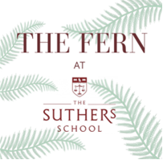
The Fern is our library, learning and careers hub at The Suthers School, aptly named after our location in Fernwood and in line with our TORCH tree emblem. We use the motto ‘Learn at The Fern’ as we have dedicated space for students to read, study and research. Students are able to access The Fern in their lunchtimes and during enrichment sessions. KS3 English lessons also take place in The Fern once per week to support our Accelerated Reader programme. We host termly events for students, parents and carers in The Fern including book stalls and workshops to support parents and carers with how to develop reading for pleasure at home. We also provide students with an opportunity to engage with competitions and reading-related events throughout the year, as well as exposing them to author talks and community events.

ENGLISH

Year 9 Content Summary
Through the continued study of high-quality texts and the creation of their own, students will establish their own informed voice in a range of formats, genres and contexts. They will apply their knowledge of the place and power of written and spoken language and their understanding of a diverse range of critical lenses. Students will develop their own personal oral and written responses, use their voices to withhold judgement of others and encourage the betterment of society, as other writers, readers and orators have done before them.

Our Year 9 Long Term Plan:
- Half Term One: Poetry of the Other
- Half Term Two: Writing Your Identity
- Half Term Three: Dystopian Fiction and 1984 by George Orwell
- Half term Four: Dystopian Fiction and 1984 by George Orwell
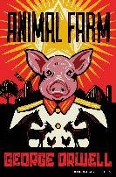
- Half Term Five: The Crucible by Arthur Miller
- Half Term Six: The Crucible by Arthur Miller

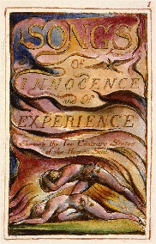
Reading preparation:
Animal Farm by George Orwell
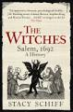
Songs of Innocence and Songs of Experience by William Blake
The Witches: 1692 Salem by Stacey Schiff

Useful website links:
www.freerice.com – A UN initiate to help end world hunger, one word
at a time.
https://www.bbc.co.uk/bitesize/subjects/z3kw2hv - A student zone focused on KS3 English skills

GCSE exam and exam board:
AQA English Language GCSE
AQA English Literature GCSE

MATHEMATICS

Year 9 Content Summary
Mathematics is a fascinating, enthralling subject that is vital in everything that we do. Fostering a love of learning the subject and appreciating the beauty of Mathematics are key elements that underpin the curriculum at the Suthers School.
The Mathematics curriculum, informed by educational research and exceeding the demands of the National Curriculum, has been carefully crafted and sequenced to be ambitious for all students, no matter of their starting point.
Topics are broken down into small connected and structured steps, each one acting as a building block for the next. Year groups study the ‘story’ of a topic as they progress from one year to the next, with their depth of their knowledge of the story increasing over time.
The first topic students in Year 9 will study is sequences, where students will be developing their knowledge from their Year 7 and 8 story and learning to generate and use quadratic sequences, drawing upon prior knowledge and use of the square numbers. Students then move onto writing and working with numbers in standard form, making cross-curricular links with Science and learning about the reasons why numbers are written in this way and famous real-world examples, such as writing the speed of sound or the diameter of an electron.
The Mathematics curriculum at the Suthers School empowers all students by:

- Stimulating, developing and nurturing the passion of all students
- Equipping students with the tools to become resilient problem solvers
- Developing the school wide character strengths in every lesson
- Identifying misconceptions to anticipate common mistakes and increase understanding for all
- Exploring historically, current and culturally important Mathematicians and Mathematical events
- Making links to further and higher education and careers
- Delivering a consistent focus on real world applications of Mathematics
- Narrowing the vocabulary gap, by promoting a high level of oracy, giving all students the opportunity to talk like an expert
- Making connections between topics through careful and effective sequencing
- Making cross curricular links to other subjects

Useful website links:
Corbettmaths.com
Mathsgenie.co.uk
Mrbartonmaths.com
Nrich.maths.org

GCSE exam and exam board:
AQA GCSE Mathematics
SCIENCE

Year 9 Content Summary- Students will study a range of topics within the domains of biology, chemistry and physics, interleaving ‘working scientifically’ skills throughout.
Our bespoke curriculum builds on the scientific principles learnt during Years 7 & 8, such as the periodic table, energy and reproduction, whilst preparing students for the greater demands of GCSE Science in Year 10.
We deliver the following content in Year 9:
Biology | Chemistry | Physics
- Cells | - Particle Model & State Change | - Forces & Motion
- Cell Systems | - Atoms & the Periodic Table | - Energy
- Fertilisation & Implantation | - Chemical Changes | - Waves, Sound & Light
- Variation & Natural Selection | - Useful Chemical Reactions | - Electricity & Magnetism

Each carefully chosen topic identifies the most important concepts that will help to further students’ scientific understanding, whilst making contextual links to society and the natural world. Practical activities are meticulously planned to support students’ learning and to encourage the development of investigative skills.
Home learning tasks are frequently used to support, supplement and extend the learning that takes place in the classroom, whilst encouraging students to be independent thinkers.
Reading preparation:
No additional resources are required to access our curriculum. However, if you are keen to expand your horizons and wish to learn more about science, then you might like to try the following publications:
For our curriculum:
- Any ‘CGP KS3 Science’ study guide or workbook is a beneficial learning aid
Just for fun:
- Unlocking the Universe (Stephen & Lucy Hawking)
- Gory Details: Adventures from the Dark Side of Science (Erika Engelhaupt)
- A Short History of Nearly Everything (Bill Bryson)
- What If (Randall Munroe)
Useful online resources:
- Cells Alive!
GCSE examination options and exam board:
All KS4 students study either: AQA GCSE Combined Science: Trilogy (2 GCSEs), or can opt for separate GCSEs in Biology, Chemistry & Physics.
- Learn Genetics (Utah)
- oPhysics: Interactive Physics Simulations
- BBC Bitesize KS3 Science

PHYSICAL EDUCATION

Year 9 Content Summary

Students will participate in a variety of activities this year including… Fitness, Football, Rugby, Netball, Basketball, Gymnastics, Outdoor activity, Hockey, Badminton, Rounders, Cricket, and Athletics
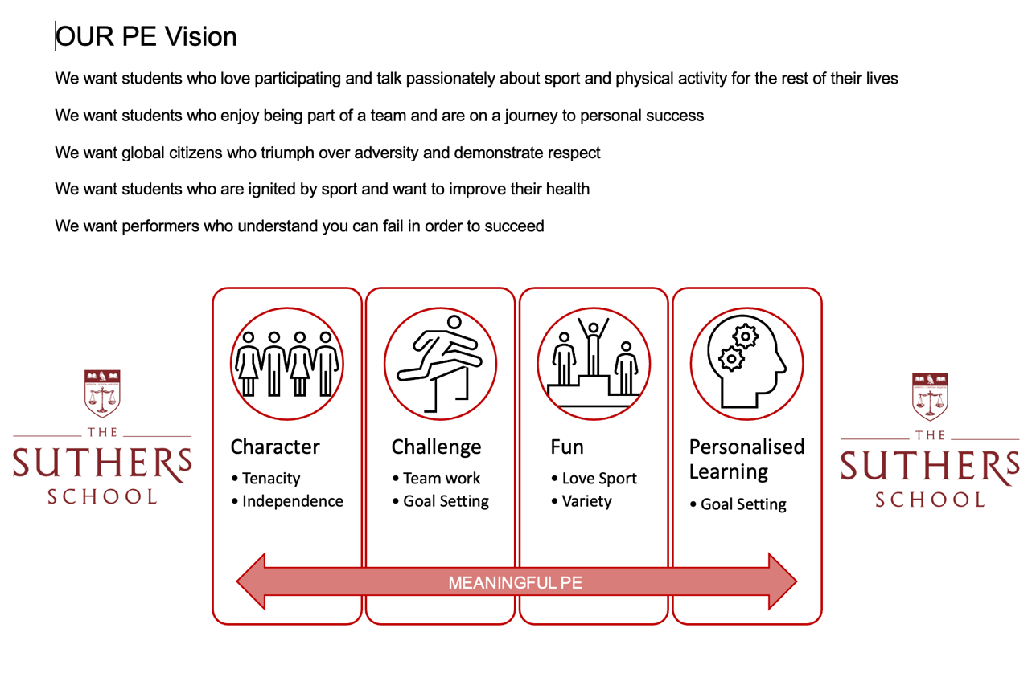
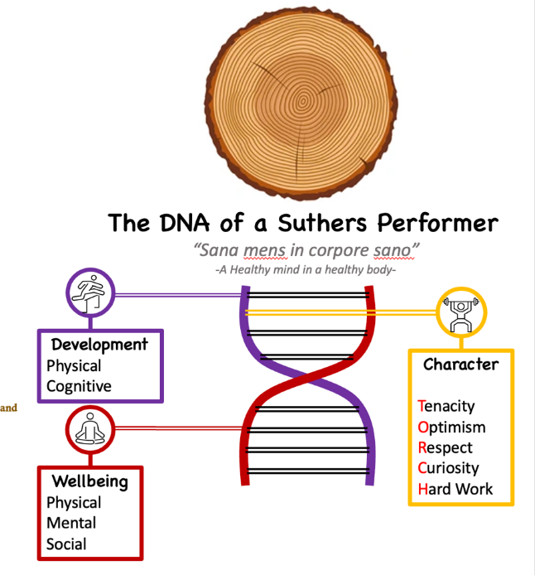
Students will learn rules and regulations for all sports through the exploration of core and advanced skills. These are taught in isolation or in controlled practices. They will use this to gain confidence and an understanding of the sport.

Pupils check their progression against our assessment benchmarks and set targets to improve. They also will learn about health and physical themes which affect physical activity and how they can overcome barriers to be successful.

Current GCSE course:
OCR Cambridge National Sport Studies

PERSONAL DEVELOPMENT

Year 9 Content Summary-
We support students to navigate their way around the complex world of careers, relationships and influences.
Through a carefully sequenced series of 1-hour timetabled lessons they explore the following topics:
- Future Self and Ambitions
- Intimate Relationships
- Resilient Relationships
- Drugs and Alcohol (including Vaping)
- Gangs and County lines
- Below is a chart of what these topics will include, the colours refer to the different strands of the PD curriculum.
Health Education
Relationships Education (ReE) and Relationships and Sex Education (RSE)
Living in the Wider World

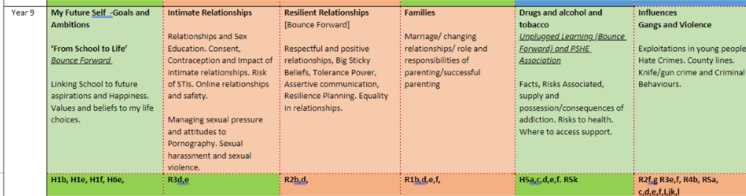
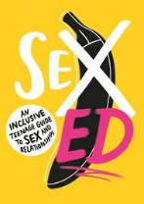
Reading preparation: Students will be reading extracts from ’School of Sex Ed, an Inclusive Teenage Guide’
Useful website links:
https://bounceforward.com/healthy-minds-for-secondary/

https://www.childline.org.uk/info-advice/
In addition we work with the following organisations to deliver our PD curriculum. All resources are carefully adapted and sequenced to meet the needs of our students.
- The Healthy Minds Curriculum in association with Bounce Forward (delivered by our accredited lead teacher).
- The PSHE Association.
- The Home Office – example ‘Disrespect Nobody’
- The Sex Education Forum.
- WE Schools UK
- CEOP
- Barclaycard Life Skills
- Unifrog
- Sexions NHS

HISTORY

Year 9 content summary
Students will continue their exploration of the 20th century from their Year 8 studies, gaining detailed knowledge and understanding of the complex ways in which change has impacted, not only the lives of those who experienced them first hand, but also people today. They will explore themes of power, belief and conflict to compare and contrast modern day societies with those from earlier periods they have studied. Key topics this year include:
- Causes of World War Two – Students will look at the challenges that faced peacemakers in the aftermath of World War One. The Treaty of Versailles will be investigated and analysed to see how this impacted individual nations’ foreign policy on world events. The involvement of the USA and USSR will also be considered in the build up to World War Two.
- World War Two – This unit looks key events that took place during the war including the Battle of Britain, The Blitz, Pearl Harbour and Battle of Stalingrad. Students will look at civilian experiences in Britain and abroad to understand the challenges people faced. Students will also examine the causes and consequences of the Atomic Bomb being dropped in 1945.
- The Holocaust – Students will look at the journey that Jewish people went on, starting with the roots and developments of anti-Semitism. They will look at what Jewish life was like in Europe before, during and after the rise of Hitler. Students will also look at Holocaust and genocide survivors’ stories to understand what happened during the many dark years people faced. We will finish by looking at the legacy of the Holocaust.
- Cold War – We will consider the growing tension between the East and West, before, during and after the World Wars. Students will get a better understanding of the terms communism and capitalism and understand how these ideologies divided the world and led to a time of constant tension. Key events that will be looked at include the Arms Race, Space Race, Cuban Missile Crisis, Vietnam War and the Berlin Wall.
- Civil Rights Movement – Students will assess the difference in black lives before and after American emancipation. We will look at the stories of unity and conflict between those fighting for change and build connections with South Africa and the Apartheid.
- 21st century change– Through a student voice, students will be able to choose what they would like to learn about, which has happened in the last twenty years. Events last year included what happened at 9/11, London 7/7 bombings and conflict with Russia and Ukraine. This unit is important in making sure all students understand the world they live in, what Is happening and why it is happening.
Useful website links:
https://senecalearning.com/en-GB/
GCSE Exam and Exam Board:
Health and the People (AQA)
Elizabethan England (AQA)
Conflict and Tension: Interwar 1919-1939 (AQA)
Germany 1890-1945 Democracy and Dictatorship (AQA)
GEOGRAPHY
Year 9 Content Summary: Student’s physical geography knowledge develops into resource management and economic development. They will consider the conflict between physical, economic and human challenges and opportunities, through a more diverse lens. Students will develop their moral, ethical and environmental judgement on dilemmas facing the world.
Students will study the following units over the year:
- Russia – is the geography of Russia a curse or a benefit to its development?
- UK landscapes – which physical processes have carved the UK landscape?
- Natural resources – how do we use our planet for economic gain?
- Climate change – how is the world responding to the climate emergency?
- Middle East – why has the Middle East developed unevenly?

All units in year 9 will also deliver careers education as part of the curriculum, along with Literacy and Numeracy skills, map skills and oracy.

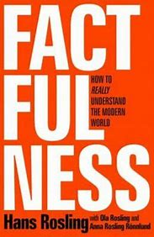
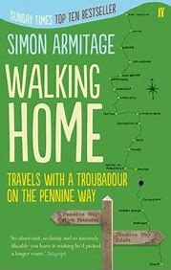
Reading preparation:
Factfulness: Hans Rosling
Prisoners of Geography: Tim Marshall
Walking Home: Simon Armitage

Useful website links:
KS3 Geography - BBC Bitesize
Russia facts - National Geographic Kids (natgeokids.com)
A Guide to Climate Change for Kids | NASA Climate Kids
GCSE exam and exam board:
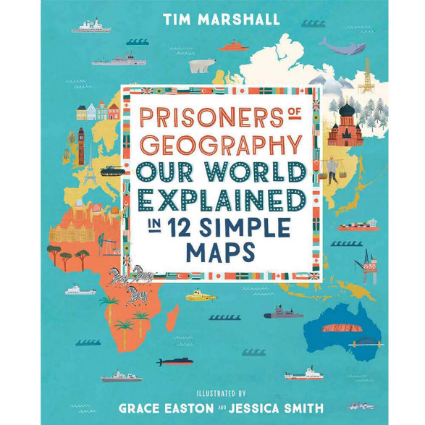
AQA Geography

DESIGN TECHNOLOGY

Year 9 Content Summary- Students will study Hospitality, Catering, graphics, CAD/CAM and product design
Students will complete a range of projects during their second year in Design Technology. Students will complete technology projects that will last predominantly for 9 weeks in duration. We currently deliver the following projects in year 9:
- Lamp project- An introduction to electronics where students design and manufacture an LED desk lamp. The lamp enables students to learn about engineering drawings which then support them to manufacture a range of wood joints. Students also use CAD/ CAM to enhance their product
- Hospitality & Catering- Head chef award. This project enables students to make an informed decision regarding the possibility of taking Hospitality & Catering as an option in year 9. Students help to plan and deliver a catering event
- Christmas project -Introduction to CAD/ CAM to manufacture a Christmas tree decoration
- Engineering Design- a transition project to help students make an informed decision about the possibility of taking Engineering Design as one of their options for year 10. This will be a design and make project incorporating CAD/ CAM, technical drawing and manufacturing.
All projects in year 9 will also deliver careers education as part of the curriculum. Throughout the year students will work towards the following certificates in Design Technology:

 | Year 7 | Year 8 | Year 9
Design | Design apprentice | Product Designer | Engineering apprentice
Food | Porter and Chef de partie | Sous Chef certificate | Head Chef
Project focus | H&S and restaurants | Fake aways and takeaways | Careers/ options
Gatsby Bench Marks | 1,2,4 | 1,2,4,5 | 1,2,4,5
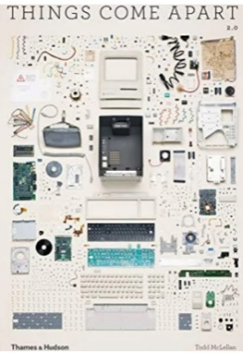
Reading preparation:
Things come apart 2: A Teardown Manual for Modern Living
Catering Business: How to start, operate and be successful with your own catering company
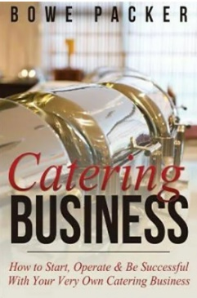
Useful website links:
Technologystudent.com
BBCgoodfood.com
GCSE exam and exam board:
Cambridge National in Engineering Design (OCR)
Cambridge National Hospitality & Catering Level 1&2 (OCR)

Year 9
COMPUTING
In year 9, learners will have exposure to computers science, IT and Business to prepare for the various GCSE qualifications that are on offer. They will learn how to think logically and how to apply computational strategies to solve problems. This will help them in their programming and coding unit. They will also learn what makes a computer system and the fundamentals of networks. Learners will have the opportunity to investigate how businesses work and to plan for their own business idea.
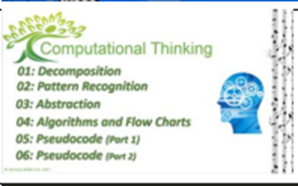 | 9.1 Computational Thinking  This unit is an introduction to the principles of programming: computational thinking. Learners will go through the three stages of computational thinking: decomposition, pattern recognition and abstraction. They will then apply those principles when they start designing their algorithms to solve everyday problems using flowcharts. This unit forms the foundation of the following unit where they will learn to program.
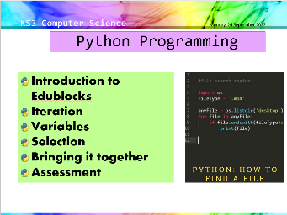 | 9.2 Python Programming  This is an introduction into the programming and coding world using interactive and fun platforms and activities. They will apply all the principles of computational thinking to write python to solve everyday problems. Learners will enjoy programming using an online platform https://edublocks.org/ where they will see their programs come to life. This platform is free and available to access anywhere with internet access.
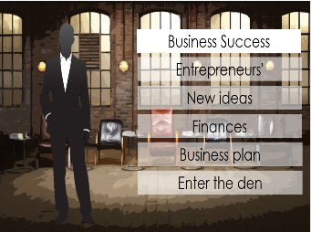 | 9.3 Dragons Den  This unit of work gives learners a glimpse into the world of how a business works. This will also give them an idea of what Enterprise and Marketing Studies really is ready for them to choose their GCSE options.
9.4 Data Representation
Gives learners an understanding of how data is represented and stored on a computer. They will study the binary number system and how numbers and characters are stored in the computer memory. They will also explore digital images and sound and learn how they are represented on the computer.

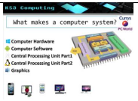 | 9.5 What Makes a Computer System  This will give learners a more in-depth understanding of the difference between hardware and software and how they both work together to make a computer system. Learners will also explore the different parts of the central processing unit and define the roles of the main parts.
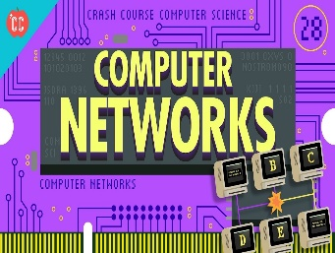 | 9.6 Networks  Gives learners an understanding of the fundamentals of networks. They will learn the main two types of networks: LAN and WAN. There will be a focus on LAN and the different topologies, Star and Mesh. Learners will also study wireless networks and investigate the advantages and disadvantages of wired and wireless networks. Finally, learners will develop an understanding of ethical issues surrounding the use of the Web and look at security risks and how they can be prevented.
Useful website links | https://hourofcode.com/uk/learn  https://www.bebras.uk/  https://scratch.mit.edu/  https://www.bbc.co.uk/bitesize/topics/zvsc7ty
CSE exam and exam board | GCSE in Computer Science (OCR)  Cambridge National in Creative iMedia Level 1&2 (OCR)  Cambridge National in Enterprise and Marketing Level 1&2 (OCR)

SOCIAL STUDIES

At The Suthers School, we believe that teaching children how to be socially responsible. During their Social Studies lessons, students will learn about different elements of politics, religion and law that will help prepare them for life in Modern Britain.
Year 9 Content Summary-

Introduction to Philosophy In this unit of work we examine some of the early Greek philosophers and look at how ancient philosophy impacts modern society? We also explore Miachiavellian philosophy and challenge the misinterpretation of Nihilism and Existentialism?

How democratic is the UK? Students critically evaluate the democratic nature of the UK. To do this we assess separation of powers in the UK, explore the nature of our electoral systems, and the role of the free media in democratic countries.

Understanding Human Rights In this unit of work we explore the development of Human Rights, from the Magna Carta to the European Convention of Human Rights and beyond. We will look at the proposed Human Rights Bill and explore how well Human Rights are protected in the UK and in other countries.
Law, religion and morality Students will explore different theories of morality, including Utilitarianism and Natural Law. We look at how morality in religion has influenced moral rules in society today, and how, in turn, moral rules influence our legal rules.
Introduction to the UK Legal System In this unit of work, students will learn about the difference between criminal and civil law, how our court systems are structures and the various people who work within the legal system.
World religions and democracies Students will examine six different democracies around the world, exploring their religious make-up, their Human Rights records and their democratic institutions.
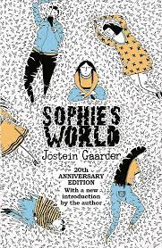

Reading preparation:
Sophie’s World by Jostein Gaarder
Law For Beginners from Usborne
Useful website links:
Parliament.uk
BBC Bitesize – KS3 Religious Studies
Byc.org.uk (British Youth Council)
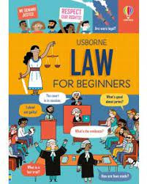

GCSE exam and exam board:
This subject prepares students for GCSES in
Citizenship
Philosophy and Ethics
Politics
Religious Studies
MUSIC
In music, year 9 students will deepen their understanding an appreciation of a range of musical styles, genres and instruments alongside developing performance skills. Through a largely practical curriculum, students will learn to read music using standard notation and perform pieces using keyboards, ukulele and percussion, alongside developing ensemble singing and composition skills.
Term 1 | Term 2
FILM AND DESCRIPTIVE MUSIC  By Completing this unit students will be able to…  Perform and compose descriptive music, define, identify and manipulate the musical elements, understand the key features of Romantic Music and film music, perform In The Hall of the Mountain King.  They will be able to understand how composers use music to add emotion to films, how to compose music by manipulating the elements of music, and  explain and demonstrate how composers used to elements of music in the Romantic Period.  Content:  Romantic Period, Grieg, film music composers, Crop Duster. | COVER VERSIONS AND SONG WRITING  By completing this unit students will be able to…  Perform and compose pop music accurately and stylistically as an ensemble on a variety of instruments.  They will develop their skills as a performer and composer, including ensemble skills. They will also further their understanding of the elements of pop music and how they are used.  Content:  Pop elements and conventions, guitar, ukulele and keyboard chords, vocal styles and skills, ensemble skills. Composing using standard chord progressions, chord/passing notes, lyrics

Wider Opportunities in Music:
We are also planning to be able to offer students the opportunity to undertake individual instrument lessons in a variety of instruments, if you would like to express your interest in your child receiving instrument lessons please complete the on-line form on the school website.

Useful Website links
https://www.bbc.co.uk/bitesize
https://www.bbc.co.uk/teach/ten-pieces

Recommended Reading
Turn it Up!: A pitch-perfect history of music that rocked the world by Michaela Weglinski
FRENCH
Year 9 Content Summary- Our curriculum is designed around up-to-date research on language acquisition. In Year 9 students will continue to acquire new language through listening extensively to model authentic texts. Students will then learn to speak, write and read fluently, using a broadening range of language (1000 words approx.), about where they live, their school and their free time. Students will become familiar with the geography and culture of France and the wider French speaking world. They will explore opportunities for travel and work provided by knowledge of French.
In Year 9 students will study the following units:

- Mes loisirs Students will learn to talk about what they do in their free time. They will talk about their hobbies and passions. Students will also talk about how their hobbies have changed over time. Students will develop their grammatical knowledge by exploring how to use different tenses.

- Le weekend dernier Students will build on the previous unit’s work by learning to talk about what they did last weekend, including any sports they did and other leisure activities. They will also talk about where they went. Students will develop their grammatical knowledge by looking in depth at the perfect tense.

- Les vacances Students will learn to talk what they do in the school holidays, including travelling in the UK and abroad. Students will also talk about their ideal holidays and where they would go if they had the choice. Students will develop their grammatical knowledge by learning to use the conditions tense.

- L’environnement Students will learn to talk about threats to the environment. They will also talk about what one should do to protect the environment. Students will develop their grammatical knowledge by exploring the modal verb “il faut.”
Regular “Culture Capital” activities ensure that students also develop an awareness of the culture of France and the wider French speaking world. In each year of Key Stage 3, students will also study a French language film.
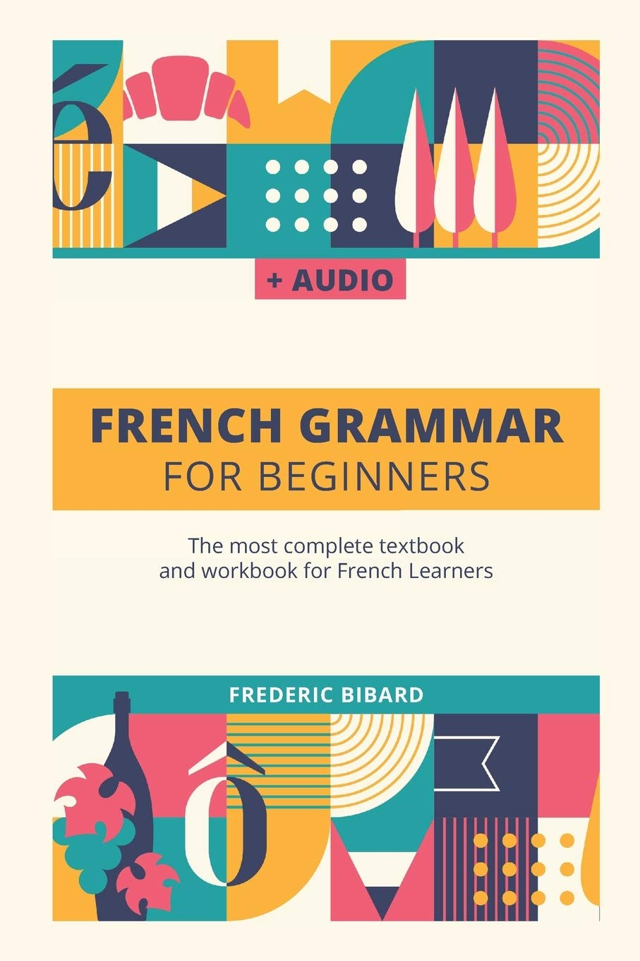

Reading preparation:
French Grammar for Beginners by Frederic Bibard
Useful website links:
Duolingo (Website or App)
BBC Bitesize – KS3 French
GCSE exam and exam board:
GCSE French - AQA

